Aequs EduTrack — User Manual

Aequs Foundation Education Tracking & Management Portal

Product | Aequs EduTrack
Version | 2.0
Date | August - September 2026
Organization | Aequs Foundation
Platform | Web Application (Django)

Table of Contents

1. Introduction
2. Getting Started
3. Dashboard
4. Schools Management
5. Student Management
6. Academics
7. Eligibility Management
8. Inventory Management
9. Distributions
10. Internships
11. Events
12. Volunteers
13. Reports
14. Admin Console
15. User Roles & Permissions
16. FAQ & Troubleshooting

1. Introduction

1.1 About Aequs EduTrack
Aequs EduTrack is a comprehensive education tracking and management portal developed for the Aequs Foundation. It is designed to digitally manage the Foundation's CSR education initiatives, including:
- Tracking students across government schools in the Belagavi district of Karnataka
- Monitoring academic performance year over year
- Determining student eligibility for benefits (books, laptops, study kits, internships)
- Managing inventory of educational materials and assets
- Recording distributions of resources to students and schools
- Facilitating corporate & industrial internship placements at Aequs SEZ
- Coordinating foundation events and volunteer participation
- Generating reports for stakeholders and auditors

1.2 System Requirements
Requirement | Specification
Browser | Google Chrome (v100+), Mozilla Firefox (v100+), Microsoft Edge (v100+), Safari (v15+)
Internet | Stable broadband connection
Device | Desktop or Laptop (primary); Tablet (supported)

2. Getting Started

2.1 Accessing the Application
Open your web browser and navigate to the Aequs EduTrack URL provided by your system administrator.

2.2 Logging In
1. On the Login page, you will see the Aequs Foundation branding with a secure login card.
2. Enter your Username in the first field.
3. Enter your Password in the second field.
4. Click the Sign In button.

[!IMPORTANT]
If you see the message "Invalid username or password. Please check your credentials.", verify that your username and password are correct. Contact your System Administrator if the issue persists.

2.3 Logging Out
1. In the sidebar (left panel), scroll to the bottom.
2. Click the Log Out button (displayed in red).
3. You will be redirected to the Login page.

2.4 Navigation Overview
The application uses a fixed sidebar on the left for navigation. The sidebar is organized into three sections:

Core Management
Menu Item | Icon | Description
Dashboard | Layout Dashboard | Home page with KPI summary and recent activity
Schools | School | Government school registry and management
Students | Graduation Cap | Student enrollment, profiles, and records
Academics | Book Open | Academic performance records

Programs & Benefits
Menu Item | Icon | Description
Eligibility | Check Circle | Benefit eligibility checks and records
Inventory | Laptop | Asset and material stock management
Distributions | Package | Record and track resource distributions
Internships | Briefcase | Corporate internship programs and placements

Foundation
Menu Item | Icon | Description
Events | Calendar | Foundation event scheduling and management
Volunteers | Users | Volunteer registration and activity tracking
Reports | Bar Chart | Analytics and downloadable reports

At the very bottom of the sidebar you will find:
- Admin Console — Links to the Django Admin backend (staff only)
- Log Out — Ends your session
- User Profile — Shows your name and role

3. Dashboard
The Dashboard is the landing page after login. It provides a real-time summary of the Foundation's key metrics.

3.1 Welcome Banner
A branded welcome banner at the top greets you with:
- The logged-in user's name
- A brief description of the Aequs Foundation's mission
- Quick-access action buttons

3.2 KPI Summary Cards
The dashboard displays key performance indicators in card format:

Metric | Description
Active Schools | Number of government schools with Active status
Total Students | Total enrolled students across all schools
Active Students | Students with Active enrollment status
Academic Records | Total academic performance records on file
Eligible Students | Students currently eligible for at least one benefit
Eligible Records | Total eligibility entries marked as eligible
Internship-Eligible | Students eligible specifically for internship programs
Available Laptops | Laptops in stock with Available status
Issued Laptops | Laptops currently issued to students
Internship Placements | Total internship placement records
Active Interns | Students currently in Selected or In Progress internship status
Total Distributions | Number of distribution records
Students Benefited | Unique students who have received at least one distribution

3.3 Recent Activity Feeds
The dashboard shows the most recent 10 entries in each category:
- Recent Eligibility Checks — Latest eligibility evaluations with student name and result
- Recent Laptop Assignments — Latest laptop issues with student and asset details
- Recent Internship Placements — Newest internship records with program and status
- Recent Distributions — Latest material distributions with recipient and type

4. Schools Management
The Schools module manages the registry of partner government schools.

4.1 Schools Portal
Navigate to Schools in the sidebar to access the Schools Portal. This is the primary interface offering a combined view of:
- School listing with search and filter capabilities
- School detail view
- School creation and editing forms

4.2 Viewing Schools
The schools list displays all registered government schools with the following information:
Field | Description
Name | Official school name
UDISE Code | Unique government-issued school identification code
District | District location (e.g., Belagavi)
Taluk | Taluk/sub-district
Village | Village or locality
Pincode | Postal code
Headmaster | Name of current headmaster
Phone | School contact number
Email | School email address
Student Strength | Current student enrollment count
Status | Active or Inactive

4.3 Adding a New School
1. Click the Add School button in the Schools portal.
2. Fill in the required fields:
  - Name (required)
  - UDISE Code (required, must be unique)
  - Address (required)
  - District (required)
  - Headmaster Name (required)
3. Fill in optional fields as available: Taluk, Village, Pincode, Phone, Email, Student Strength, Established Year.
4. Click Save to create the school record.

[!TIP]
The UDISE code is a government-assigned identifier. Verify this code from official records before entry, as it must be unique in the system.

4.4 Bulk Upload
Schools can be uploaded in bulk using a CSV file:
1. Click Bulk Upload in the Schools portal.
2. Download the CSV template provided.
3. Fill in school data following the template format.
4. Upload the completed CSV file.
5. Review the preview and confirm the import.

5. Student Management
The Students module manages all student enrollment records.

5.1 Student List
Navigate to Students in the sidebar. The student list displays all enrolled students sorted by most recent entry, with columns for:
Field | Description
Admission Number | Unique student admission ID
Student Name | Full name of the student
Gender | Male, Female, or Other
School | Associated government school
Current Class | Current class/grade (e.g., Class 10, 2nd PUC)
Section | Class section (e.g., A, B)
Roll Number | Class roll number
Parent/Guardian Name | Name of parent or guardian
Parent Phone | Parent's contact number
Status | Active, Transferred, Passed Out, or Inactive

5.2 Adding a Student
1. Click Add Student in the Students section.
2. Fill in the registration form:Required Fields:Optional Fields:
  - Admission Number (must be unique)
  - Student Name
  - Gender (Male / Female / Other)
  - School (select from dropdown)
  - Current Class
  - Parent Name, Parent Phone, Parent Email, Relationship to Student
  - Date of Birth, Section, Roll Number
  - Parent Phone, Parent Email, Relationship to StudentStudent Phone, Student Email, Address
  - Status (defaults to Active)
  - Admission Date, Photo
3. Click Save to register the student.

5.3 Student Detail View
Click on any student's name in the list to view their full profile, including:
- Personal information and contact details
- School enrollment details, Academic history (linked from the Academics module)
- Eligibility records, Laptop assignments, Distribution history
- Internship placements

5.4 Bulk Student Upload

For mass enrollment:
1. Click the Bulk Upload option.
2. Download the CSV template.
3. Fill in the student data in the CSV file.
4. Upload the file and review the import preview.
5. Confirm to complete the bulk import.
[!WARNING]
Ensure each admission_number is unique. Duplicate admission numbers will cause the import to fail for those rows.

6. Academics
The Academics module tracks student academic performance records across academic years.

6.1 Academics Portal
Navigate to Academics in the sidebar to access the full-featured Academics Portal with search, filter, and data management capabilities.

6.2 Academic Record Fields
Field | Description
Student | The student this record belongs to
Academic Year | Academic year (e.g., 2025-26)
Class / Course | Class or course name (e.g., Class 10, 2nd PUC, Degree)
Marks Obtained | Total marks scored
Total Marks | Maximum possible marks
Percentage | Calculated percentage
Rank | Class or school rank (if applicable)
Previous Class | The class the student was in before this year
Promotion Status | Whether the student was promoted, retained, etc.
Transfer School | If transferred, the destination school
Remarks | Any additional notes

6.3 Adding an Academic Record
1. Click Add Record in the Academics portal.
2. Select the Student from the dropdown.
3. Enter the Academic Year (e.g., 2025-26).
4. Fill in Class/Course, Marks Obtained, Total Marks, and other relevant fields.
5. Click Save.

6.4 Editing and Deleting Records
- Edit: Click the edit icon on any record to modify it.
- Delete: Click the delete icon. A confirmation dialog will appear asking you to confirm deletion.
[!CAUTION]
Deleting an academic record is permanent. Ensure you have the correct record selected before confirming deletion.

6.5 Bulk Upload
Academic records can also be uploaded in bulk via CSV following the same workflow as student bulk uploads.

7. Eligibility Management
The Eligibility module determines and records which students qualify for foundation benefits.

7.1 Eligibility Portal
Navigate to Eligibility in the sidebar to access the Eligibility Portal with comprehensive filtering and evaluation tools.

7.2 Benefit Types
Students can be evaluated for eligibility across the following benefit categories:
Benefit Type | Code | Description
Books | BOOK | Textbooks and reference materials
Workbooks | WORKBOOK | Practice workbooks and exercise materials
Study Kit | STUDY_KIT | Complete study material kits
Laptop | LAPTOP | Laptop devices for educational use
Internship | INTERNSHIP | Corporate internship placement at Aequs SEZ

7.3 Eligibility Record Fields
Field | Description
Student | The evaluated student
Benefit Type | Which benefit is being evaluated
Academic Year | The year of evaluation
Eligible | Whether the student is eligible (Yes/No)
Selection Rank | Priority rank among eligible students
Reason | Justification for the eligibility decision
Checked At | Timestamp of the last evaluation

7.4 Evaluating Eligibility
1. Open the Eligibility Portal.
2. Select or search for the student.
3. Choose the Benefit Type being evaluated.
4. Set the Academic Year.
5. Mark as Eligible or Not Eligible.
6. Optionally add a Selection Rank and Reason.
7. Save the record.

[!IMPORTANT]
Each student can have only one eligibility record per benefit type per academic year. The system enforces this uniqueness constraint automatically.

8. Inventory Management
The Inventory module provides complete warehouse and asset management for the Foundation's educational materials.

8.1 Inventory Portal
Navigate to Inventory in the sidebar to access the comprehensive Inventory Portal. The portal is divided into two major sections:

1. General Inventory — Books, workbooks, study kits, school essentials, event materials
2. Laptop Management — Individual laptop asset tracking and assignment

8.2 General Inventory Items

Item Categories
Category | Description
Books | Textbooks, reference books
Workbooks | Practice and exercise workbooks
Study Kits | Pre-assembled kits of study materials
Laptops | Laptop devices (also tracked individually below)
School Essentials | Benches, desks, whiteboards, lab equipment, etc.
Event Materials | Materials used for foundation events

Item Fields
Field | Description
Item Name | Descriptive name of the item
SKU | Stock Keeping Unit / unique item code
Category | One of the categories listed above
Unit | Measurement unit (Pieces, Sets, Packs, Units)
Current Stock | Quantity currently in stock
Low Stock Threshold | Stock level that triggers a low-stock alert
Unit Cost | Cost per unit in INR
Location | Physical storage location (warehouse/room/shelf)
Status | Active or Inactive

Stock Status Indicators
Status | Condition
🟢 In Stock | Current stock is above the low-stock threshold
🟡 Low Stock | Current stock is at or below the threshold
🔴 Out of Stock | Current stock is zero

8.3 Stock Transactions

Every stock change is recorded as a transaction for full audit traceability:

Transaction Type | Description
Stock In | New stock received (from supplier/vendor)
Stock Out | Stock issued out (to school/student/event)
Stock Adjustment | Manual correction of stock levels

Each transaction records:
- Quantity moved
- Previous stock level → New stock level
- Source/Destination (vendor, school, student, etc.)
- Reference number (PO, Invoice, Voucher)
- Performed by (staff name)
- Transaction date
- Notes

8.4 Laptop Management

Laptop Registry

Each laptop is tracked individually as a fixed asset with:

Field | Description
Asset Number | Internal asset ID (unique)
Serial Number | Manufacturer serial number (unique)
Brand | Manufacturer (e.g., Dell, HP, Lenovo)
Model Name | Specific model identifier
Purchase Date | When the laptop was purchased
Purchase Cost | Cost in INR
Condition | New, Good, Fair, or Damaged
Status | Available, Issued, Returned, Damaged, Lost, Retired, or Replaced
Warranty Expiry | Warranty end date

Laptop Status Lifecycle

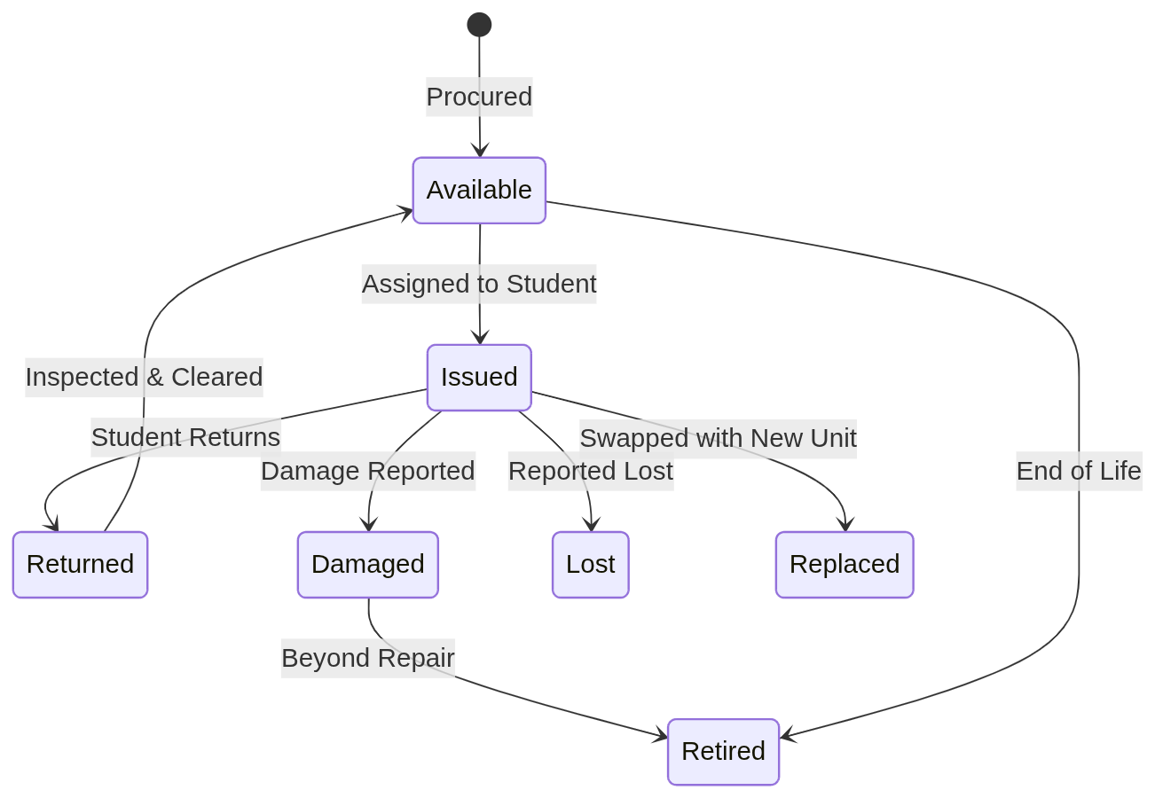

Laptop Assignment

To assign a laptop to a student:
1. Open the Inventory Portal.
2. Navigate to the Laptop Assignment section.
3. Select the Laptop (only Available laptops appear).
4. Select the Student.
5. Enter the Academic Year.
6. Add any Issue Notes.
7. Click Save — the laptop status automatically changes to Issued.

To process a return:
1. Locate the assignment record.
2. Set the Returned Date.
3. Change status to Returned.
4. Add Return Notes (e.g., condition upon return).
5. Save — the laptop status reverts to Available or is marked as Damaged based on condition.

8.5 Bulk Upload

Inventory items can also be imported via CSV bulk upload.

9. Distributions

The Distributions module records every distribution of materials and resources to students and schools.

9.1 Distribution List

Navigate to Distributions in the sidebar. The list shows all distribution records sorted by date (newest first).

9.2 Distribution Record Fields

Field | Description
Benefit Type | Books, Workbook, Study Kit, Laptop, or Government School Essential
Recipient Type | Student (individual) or Government School (bulk)
Student | The recipient student (for student-level distributions)
School | The recipient school (for school-level distributions)
Study Kit | Linked study kit definition (if applicable)
Essential Item Type | Specific school essential (Benches, Desks, etc.)
Inventory Item | Linked inventory item for real-time stock sync
Academic Year | Distribution year (e.g., 2026-27)
Quantity | Number of units distributed
Distribution Date | Date of distribution
Issued By | Staff member who processed the distribution
Remarks | Additional notes

9.3 Recording a Distribution

1. Click Add Distribution (or the "+" button).
2. Select the Benefit Type.
3. Choose Recipient Type:
  - Student: Select the student from the dropdown.
  - Government School: Select the school from the dropdown.
4. If distributing a Study Kit, select the kit definition.
5. If distributing a School Essential, specify the item type (Benches, Desks, Whiteboards, etc.).
6. Link the Inventory Item for automatic stock deduction.
7. Enter the Quantity, Distribution Date, Issued By, and any Remarks.
8. Click Save.

[!TIP]
When an inventory item is linked, the stock is automatically decremented by the distribution quantity, creating a Stock Out transaction for audit purposes.

9.4 Study Kits

Study kits are pre-defined bundles of materials that can be customized:

- Study Kit Definition: Named kits (e.g., "Primary STEM Kit", "High School Kit") with target grade levels.
- Study Kit Items: Individual items within a kit (e.g., Geometry Box, Notebooks, Drawing Pad, Color Pencils) with quantities per kit.

9.5 School Essential Types

When distributing to government schools, the following essential types are available:

Type | Description
Benches | Classroom benches
Desks | Student desks
Chairs | Chairs for students or staff
White Boards | Classroom whiteboards
Library Books | Books for the school library
Laboratory Equipment | Science lab apparatus
Water Filters | Drinking water purification
Fans | Classroom cooling fans
Sports Kits | Sports and PE equipment
Projectors | Digital classroom projectors
Other | Other educational resources

10. Internships

The Internships module manages the Aequs Foundation's corporate and industrial internship programs.

10.1 Internships Portal

Navigate to Internships in the sidebar to access the comprehensive Internships Portal.

10.2 Internship Programs

Creating a Program

An internship program defines a specific track or batch:

Field | Description
Title | Program name (e.g., "Aequs Aerospace Precision Engineering Internship")
Program Code | Unique code (e.g., AEQ-INT-2026-01)
Company Name | Hosting company (default: Aequs Aerospace SEZ)
Department | Department within the company
Location | Physical location (default: Belagavi SEZ, Karnataka)
Duration (Months) | Length of internship (default: 3 months)
Stipend Amount | Monthly stipend in INR (default: ₹8,000)
Total Slots | Maximum number of interns
Academic Year | Program year
Start / End Date | Program dates
Eligibility Criteria | Who can apply
Mentor In Charge | Supervising mentor name and contact
Status | Open for Applications, In Progress, Completed, or Closed

Available Departments

Department | Code
Aerospace Engineering | AEROSPACE_ENG
Precision Manufacturing & CNC | PRECISION_MANUFACTURING
Quality Assurance & Metrology | QUALITY_ASSURANCE
Information Technology & Systems | IT_AND_SOFTWARE
Supply Chain & Logistics | SUPPLY_CHAIN
Tool & Die Making | TOOL_AND_DIE
Finance & Commercial Operations | FINANCE_OPERATIONS
Human Resources & CSR | HUMAN_RESOURCES
General / Technical Operations | OTHER

Program Status Lifecycle

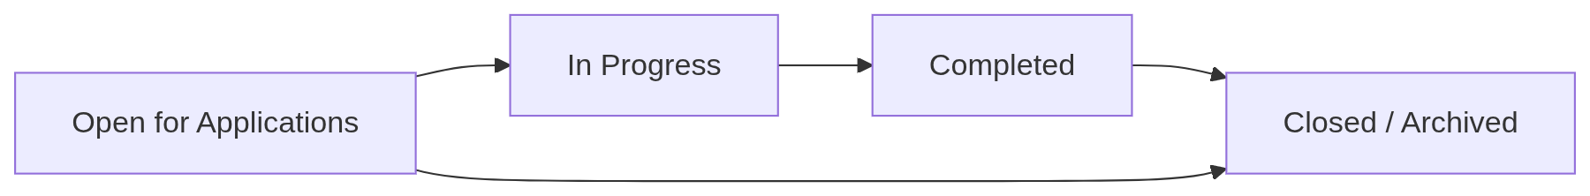

10.3 Internship Placements

A placement links a specific student to an internship program.

Placement Fields

Field | Description
Student | The intern
Program | Linked internship program
School | Student's school
Department | Assigned department
Company Name | Company where the internship takes place
Project Title | Specific project (e.g., "CNC Machine Calibration & Quality Tolerance Optimization")
Start / End Date | Internship period
Stipend Amount | Monthly stipend in INR
Mentor Name | Direct supervisor/mentor
Mentor Email / Phone | Mentor contact details
Status | Placement status (see below)
Attendance % | Attendance percentage
Performance Grade | Evaluation grade
Certificate Issued | Whether a completion certificate was issued
Certificate Number | Unique certificate identifier
Evaluation Feedback | Supervisor's performance remarks

Placement Status Flow

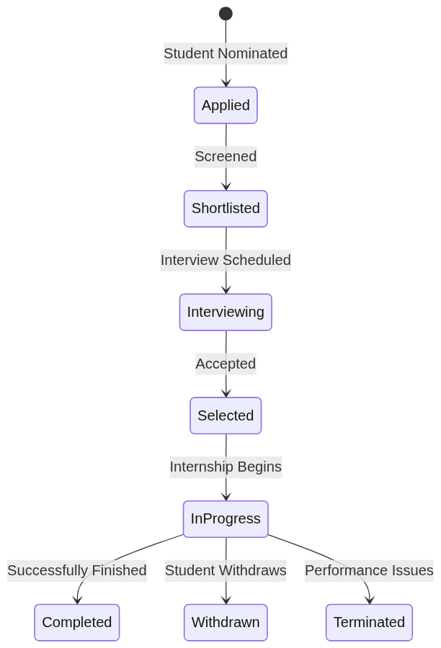

Performance Grades

10.4 Milestones

Each internship placement can have tracked milestones:

Field | Description
Title | Milestone description (e.g., "Week 4: CAD Blueprint Modelling & Simulation")
Due Date | Expected completion date
Completed Date | Actual completion date
Status | Pending, Under Mentor Review, Approved/Completed, or Needs Revision
Deliverables URL | Link to reports or project repository
Mentor Comments | Supervisor feedback

11. Events

The Events module manages foundation events such as workshops, awareness programs, and distribution drives.

11.1 Event List

Navigate to Events in the sidebar. Events are listed in reverse chronological order.

11.2 Event Fields

Field | Description
Title | Event name
Description | Detailed description of the event
Event Date | Scheduled date
Location | Venue
Organizer | Person or department organizing the event

11.3 Creating an Event

1. Click Add Event.
2. Enter the Title, Description, Event Date, Location, and Organizer.
3. Click Save.

12. Volunteers

The Volunteers module manages volunteer registration, activity tracking, and event participation.

12.1 Volunteer Registration

Navigate to Volunteers in the sidebar.

Volunteer Profile Fields

Field | Description
First Name | Volunteer's first name
Last Name | Last name
Email | Email address (unique)
Phone | Contact number
Gender | Male, Female, or Other
Date of Birth | Birth date
Address | Full address
City / State / Pincode | Location details
Occupation | Current occupation
Qualification | Educational qualification
Skills | Comma-separated list of skills
Status | Active or Inactive
Remarks | Additional notes

12.2 Volunteer Activities

Track individual volunteer activities:

Field | Description
Volunteer | The assigned volunteer
Activity Name | Name of the activity
Activity Date | Date of the activity
Description | Details of the activity
Status | Assigned, Ongoing, Completed, or Cancelled
Remarks | Notes

12.3 Event Participation

Link volunteers to foundation events:

Field | Description
Volunteer | Participating volunteer
Event | Foundation event
Role | Volunteer's role at the event
Participation Status | Assigned, Attended, Absent, or Cancelled
Hours Contributed | Total volunteer hours
Remarks | Notes

[!IMPORTANT]
Each volunteer can only be assigned to an event once. The system prevents duplicate assignments automatically.

13. Reports

The Reports module provides consolidated analytics and downloadable reports.

13.1 Accessing Reports

Navigate to Reports in the sidebar to view available report types.

13.2 Available Report Categories

Report | Description
Student Summary | Overview of student enrollment by school, class, status, and gender
Academic Performance | Analysis of academic results across years, schools, and classes
Eligibility Summary | Breakdown of benefit eligibility by type and academic year
Distribution Report | Record of all distributions by type, recipient, and period
Inventory Status | Current stock levels, low-stock alerts, and transaction history
Internship Report | Internship program utilization, placement status, and performance
Event & Volunteer Report | Event participation and volunteer contribution hours

14. Admin Console

The Admin Console provides access to Django's built-in administration interface for advanced system management.

14.1 Access

Click Admin Console at the bottom of the sidebar, or navigate to /admin/ in your browser. Only users with Staff status can access this area.

14.2 Capabilities

- Create, edit, and delete records across all modules
- Manage user accounts and permissions
- View audit logs
- Perform database-level data corrections
- Configure system settings

[!CAUTION]
The Admin Console provides direct database access. Exercise extreme caution when modifying records here, as changes bypass application-level validation in some cases.

15. User Roles & Permissions

Aequs EduTrack uses a role-based access control system with the following roles:

Role | Code | Typical Responsibilities
Super Admin | SUPER_ADMIN | Full system access, user management, system configuration
Admin | ADMIN | Module management, data entry supervision, report generation
Accountant | ACCOUNTANT | Financial records, expense tracking, inventory valuation
Volunteer | VOLUNTEER | Limited access to events, volunteer activities, and basic student info
Event Coordinator | EVENT_COORDINATOR | Event creation and management, volunteer assignment

User Profile Fields

Each user account includes:
- Username
- Password (encrypted)
- First Name / Last Name
- Email
- Phone
- Profile Photo
- Role assignment

[!TIP]
Contact your Super Admin to request role changes or new user account creation.

© 2026 Aequs Foundation. All rights reserved.
Aequs EduTrack is proprietary software developed for internal use by the Aequs Foundation.

